Dear Friend,
Welcome to the Peak Performance Programme! It is my belief that after the next 8 weeks, you will have unlocked new doors mentally and reached new levels physically and uncovered more potential emotionally.

Over our next 56 days together, you will push through your current perceived boundaries and set new standards of where your true potential lies. With immersive coaching sessions, specific action plans, like-minded people and a host of additional supportive materials along the way, it is my wish that you truly harness these next 8 weeks and use this as a catalyst to discover what you can really achieve with a mindset conditioned for success.

The new year can often act as a catalyst for people to kickstart whatever particular goal it is they wish to achieve. This experience has been designed to be the vehicle for you to create new possibilities in your life, and more specifically, in your life & mindset. The strategies, principles, behaviours and rituals that we will cover over the next month are ones that I use in my own life every single day and have coached to some of the world's leading brands. These strategies have helped me and so many others carve a life they love and helped to transform their lives, regardless of their current situation.

My life’s mission is to add extraordinary value to people’s lives and with that find the best and most successful ways to impact them in a positive way. Therefore, I hope you not only enjoy this experience the next 56 days together, but you are able to bring an intensity to your drive and commitment that will light you up long after this programme is over!

DECIDE on what it is you want to achieve, COMMIT to a month of complete immersion and mastery and strengthen your RESILIENCE to ensure that the next two months are the most transformational experience of your life both mentally and physically.

Unleash Your True Potential!
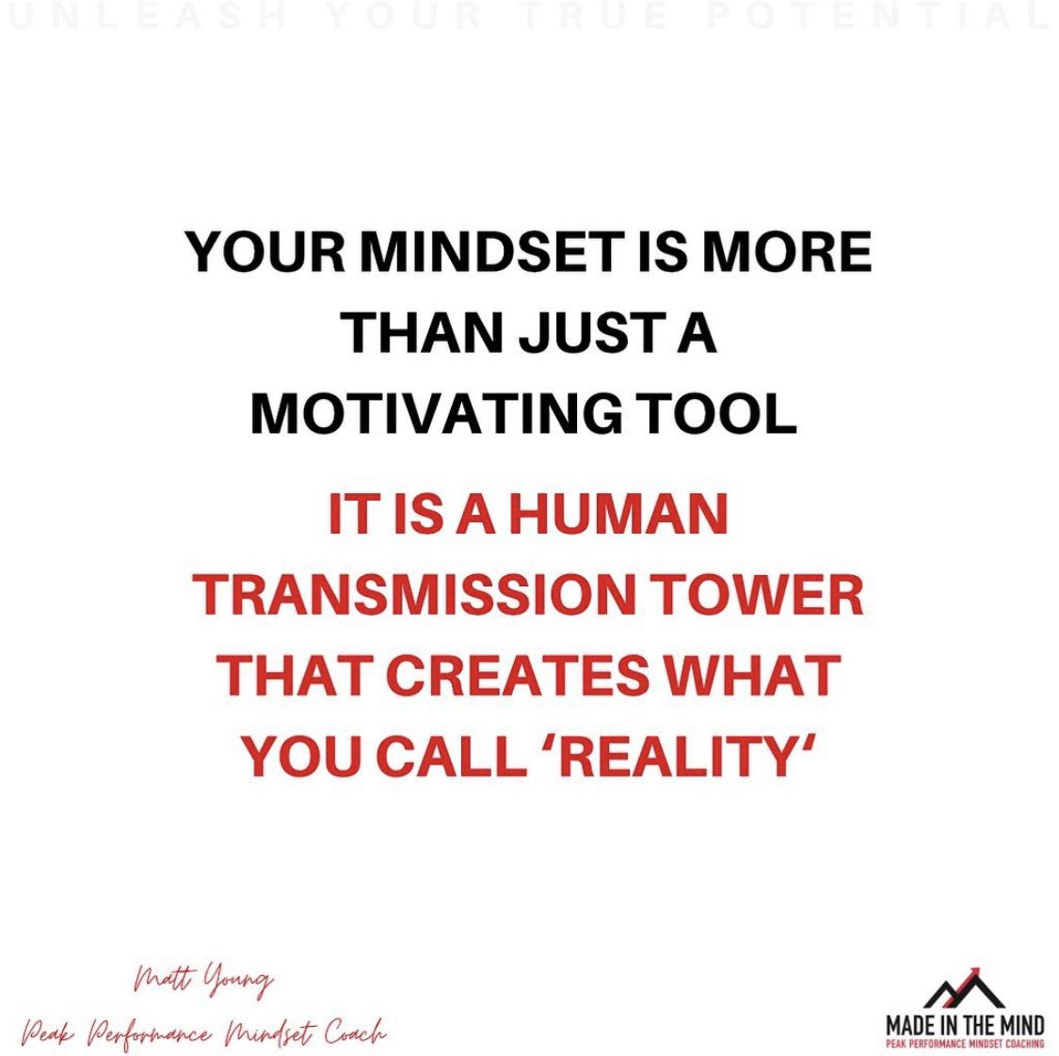

- All Live Coaching sessions will take place on ZOOM Video Conferencing and will last 60 minutes in duration.
- All Live Coaching sessions will be recorded on ZOOM, so should you not be able to make the live viewing, you can catch up via our private Facebook Group. (You will need to register a Facebook account for this).
- All Physical Workout Plans will be posted on our private app that you will have access to and able to complete at a time of your choosing.
- If the participant has any questions about how to access and sign up to this then please contact matt@madeinthemind.com.
- All ZOOM video conferencing sessions will be broadcast live.
- The participant understands that it is their responsibility to inform Matt (MADE IN THE MIND) of any previous or current injuries, health issues, or medical conditions that may be relevant and affect their participation and/or performance in the 8-week Peak Performance Programme.
- The participant understands that the Peak Performance Programme and the contents of the course do not replace the care of psychologists, physicians, dieticians or other healthcare professionals. The client acknowledges that the coaching/training provided should in no way be substituted for psychological counselling or any other form of medical or therapy advice.
- In consideration of being permitted to participate in the Peak Performance Programme, the Client knowingly and voluntarily waive any claim they may have against MADE IN THE MIND and any of MADE IN THE MIND’s coaches for injury or damages that they may sustain mentally or physically as a result of participating in the programme. The participant agrees to taking full responsibility for any risks, injuries or damages known or unknown which they might incur as a result of participating in the programme.
- The participant, their heirs or legal representatives forever agree to waive and discharge any legal proceedings against MADE IN THE MIND or any of MADE IN THE MIND’s coaches for any injury or death caused by their participation in the programme.
- It is understood that it is the participants responsibility to detail any additional information that may be considered relevant to the Peak Performance Programme before the start date of Monday 17th January 2022.
- Upon joining this 8 Week Peak Performance Programme, the participant acknowledges that all terms and conditions are in alignment with the terms set out at www.madeinthemind.com/termsconditions

NOTES:

“Change is never a matter of ability.
It will always be a matter of motivation and drive”
Matt Young
CREATING A COMPELLING FUTURE
To be able to use the next 8 weeks as a catalyst to enhance your life & mindset, you first need to become incredibly clear on what it is you are looking to achieve. Creating a compelling future is essential for anyone looking to stay committed, motivated and driven in improving their current standard of living. From this questionnaire you will become clear on exactly what it is you are aiming to achieve and more importantly WHY it is so important you do it. This questionnaire has been designed for you to gain a greater understanding into what really matters to you, and why staying committed to your goals during this programme will be so powerful.
- What does PEAK MINDSET look like to you? How do you feel? How do you act? What types of traits does this person possess?

- Why is it so important that you stay committed to your goal during this programme? What do you stand to miss out on / what are the consequences if you do not follow through and commit? What leverage do you have on yourself?
- What do you need to do for the next 56 days that will propel you towards the physical goals you want to achieve? List a minimum of 3 things.

4) What 3 new and empowering beliefs / statements can you use to reaffirm and reinforce your commitment and determination for the duration of the challenge? For example – “I am…”, “My life is going to be…”.
Reinforce these new empowering beliefs / statements daily.

“The potential of human beings is limitless.
Only our beliefs determine exactly how much potential we tap into”
Matt Young

PERFORMANCE
RRESULTS
POOR
BOTTOM OF THE BARREL
GOOD
POOR / AVERAGE
EXCELLENT
GOOD
OUTSTANDING
ALL THE REWARDS

This Performance Results System (PRS) is a powerful visual to represent the level and standard of your performance related to the direct results you will receive as a consequence of your performance level. We live in a day and age now, when a ‘good performance’ isn’t quite good enough. The standards of our society as a whole have increased exponentially, and with that, the performance required to achieve our goals have become even more demanding.
Have you ever been in a situation, whether that be at work, your home life, your physical fitness or any other part of your life, where you feel you’ve done a ‘good job’? Not outstanding, but definitely not poor. Have you ever been in this situation and felt completely underwhelmed by the results you’ve got?
A good performance no longer equals good results. The results we desire most often hide in the places we least want to go. With your physical health, it might be hidden in that extra repetition, it might be in that extra bit of determination to carry on when your mind is telling you to stop or it might be in staying committed to your nutrition plan.
To achieve all the results you could possibly desire, I challenge you, for the next 56 days, to play at a performance level that will transform your mindset and mental standing. For this programme, let’s not dabble, let’s not just ‘do a good job’. BE OUTSTANDING. Show up for yourself day after day and commit to mastery.
You will feel energy and vitality like never before and you will have experience what it is really like to UNLEASH YOUR TRUE POTENTIAL.
To perform to a ‘poor’ standard during this programme, I need to...

To perform to an ‘average’ standard during this programme, I need to...

To perform to an ‘excellent’ standard during this programme, I need to...

To perform to an ‘outstanding’ standard during this programme, I need to…

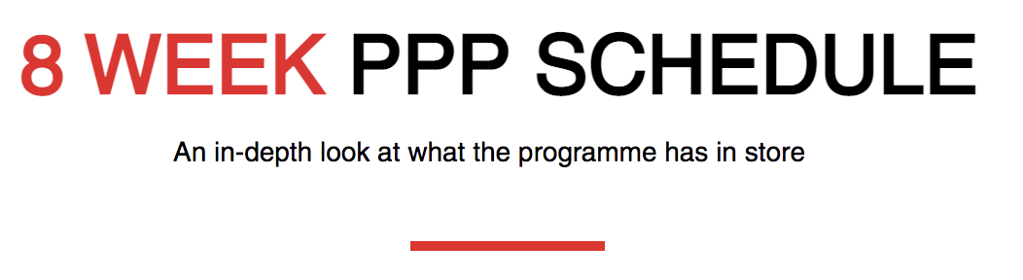

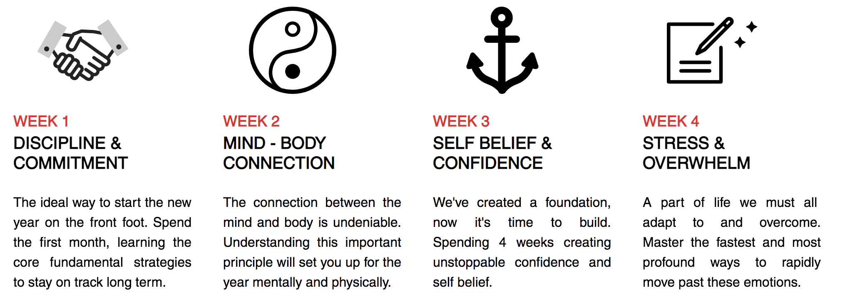

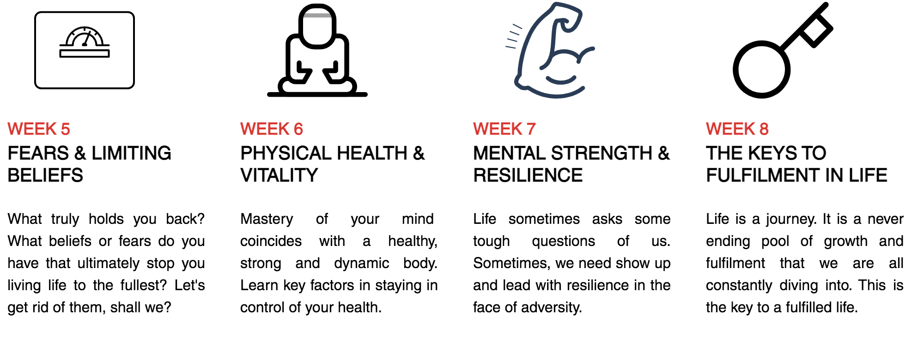

Monday Live Coaching Session: 18:00 60 mins
Bi-Weekly Q&A Session: - 30-35 mins
Use the area below to take key notes, brainstorm ideas and create plans for the week:
COMMITMENT & DISCIPLINE:
Key notes:

ACTION PLAN FOR THE WEEK:
Ideas how I can apply into my life:
Use this space below to record your progress. Note down how you feel the day went, what went well, what can you improve on and any other relevant comments.

MONDAY:

TUESDAY:

WEDNESDAY:

THURSDAY:

FRIDAY:

WEEKEND:

At the end of each week, use the space below to write down key non-negotiable habits that you have learnt, implemented and why you know this will help breed success in this area of your life:

The most important part in the process of goal achieving is having the discipline to see it through. Staying committed to a goal can often be people’s biggest downfall and leads to the main reason why people do not attain the outcomes they desire. By using this 4-step process listed below, you will create momentum within yourself and uncover new triggers and sparks of motivation to ensure you stay committed for the long haul. This process can be applied in all areas of your life where you want to commit on a deeper level.

- CREATE A COMPELLING FUTURE
As we have already discussed, to create a better quality of life and increased standard of living, we must first be clear on exactly it is we are looking to achieve. Without this first step, the rest fall by the wayside. Creating a compelling future is personal to each one of us; what matters is exactly what a compelling future is for you. Be specific, be clear, go into more detail than you think you need. Then you will gain the clarity and power needed to be able to move into action.

2) GET LEVERAGE
Once you are clear on what it is you want, you must know WHY you want it. Get leverage on yourself by finding all the reasons WHY you must change. Why is it so important you achieve this goal? What will happen if you do not achieve this goal? For most of you, you will hopefully already have tremendous leverage that will motivate you to keep taking consistent and massive action. If you do not feel like you have enough leverage, redo this step and find all the reasons why. Find the reasons that by not committing, you will receive immediate, unbearable and massive amounts of pain in your physical health and life. A powerful process that will help you with ANY goal you want to achieve.

3) SET YOURSELF NON-NEGOTIABLES
Rituals, disciplines, things that you don’t even have to second guess. To implement a new habit in order to achieve a desired result or outcome you have to create new behaviours that are non-negotiable in your day to day life. You can know exactly what you want, know exactly why it is so important to you, but if you do not implement daily habits into your life that will move you in the direction you want to go, you will ultimately find it hard to stay committed.
Create rituals in your day that are paramount. The same way you brush your teeth or have a shower, create 2 rituals that are non-negotiable!

4) GET AROUND LIKE MINDED PEOPLE
Find your Mastermind Alliance. For 56 days, you will be connecting with like-minded people, all of whom share a common goal… To create a better standard of living and increase their quality of physical health and wellbeing. But what about when the 56 days are over?
From the first 3 steps in this process you can without doubt stay committed to any goal of your choosing, but by surrounding yourself with like-minded people, you can accelerate that process. Find people who share common values and/or even goals as you. Use their energy, determination and commitment to inspire your own action. This is why a coach or mentor can be so influential. A good coach has been to where you want to go. They know the road ahead, or at very east have an understanding of what it takes to achieve your desired outcome.
You may have heard the common phrase, ‘You are the sum total of the 5 people you spend most time with’. Use this saying to create a team around you that will inspire you to take your life to the next level.

Use the area below to take key notes, brainstorm ideas and create plans for the week:
MIND / BODY CONNECTION:
Key notes:

ACTION PLAN FOR THE WEEK:
Ideas how I can apply into my life:

Use this space below to record your progress. Note down how you feel the day went, what went well, what can you improve on and any other relevant comments.

MONDAY:

TUESDAY:

WEDNESDAY:

THURSDAY:

FRIDAY:

WEEKEND:

At the end of each week, use the space below to write down key non-negotiable habits that you have learnt, implemented and why you know this will help breed success in this area of your life:

Use the area below to take key notes, brainstorm ideas and create plans for the week:
SELF BELIEF & CONFIDENCE:
Key notes:

ACTION PLAN FOR THE WEEK:
Ideas how I can apply into my life:

Use this space below to record your progress. Note down how you feel the day went, what went well, what can you improve on and any other relevant comments.

MONDAY:

TUESDAY:

WEDNESDAY:

THURSDAY:

FRIDAY:

WEEKEND:
At the end of each week, use the space below to write down key non-negotiable habits that you have learnt, implemented and why you know this will help breed success in this area of your life:

Use the area below to take key notes, brainstorm ideas and create plans for the week:
STRESS & OVERWHELM:
Key notes:

ACTION PLAN FOR THE WEEK:
Ideas how I can apply into my life:

Use this space below to record your progress. Note down how you feel the day went, what went well, what can you improve on and any other relevant comments.

MONDAY:

TUESDAY:

WEDNESDAY:

THURSDAY:

FRIDAY:

WEEKEND:
At the end of each week, use the space below to write down key non-negotiable habits that you have learnt, implemented and why you know this will help breed success in this area of your life:

Use the area below to take key notes, brainstorm ideas and create plans for the week:
FEARS & LIMITING BELIEFS:
Key notes:

ACTION PLAN FOR THE WEEK:
Ideas how I can apply into my life:

Use this space below to record your progress. Note down how you feel the day went, what went well, what can you improve on and any other relevant comments.

MONDAY:

TUESDAY:

WEDNESDAY:

THURSDAY:

FRIDAY:

WEEKEND:
At the end of each week, use the space below to write down key non-negotiable habits that you have learnt, implemented and why you know this will help breed success in this area of your life:

Use the area below to take key notes, brainstorm ideas and create plans for the week:
PHYSICAL HEALTH & VITALITY:
Key notes:

ACTION PLAN FOR THE WEEK:
Ideas how I can apply into my life:

The goals listed below are directly linked to the results I want to achieve from the 28 Day Fitness Challenge.
Use this space below to record your progress. Note down how you feel the day went, what went well, what can you improve on and any other relevant comments.

MONDAY:

TUESDAY:

WEDNESDAY:

THURSDAY:

FRIDAY:

WEEKEND:
At the end of each week, use the space below to write down key non-negotiable habits that you have learnt, implemented and why you know this will help breed success in this area of your life:

Health and nutrition are the biggest factors in ensuring you can achieve optimal energy and vitality. You can have a great mind and strong body, but if your overall health and nutrition is not sufficient enough to supply your body with what it needs, you will end up feeling sluggish, lethargic and tired. Nutrition is personal to everyone, and we all have our own individual foods, supplements, nutrients and recipes we like to use as a way of nourishing our bodies in the most effective way. However, there are some key fundamental principles that should always be adhered to, if you want to achieve optimal health, energy and vitality.

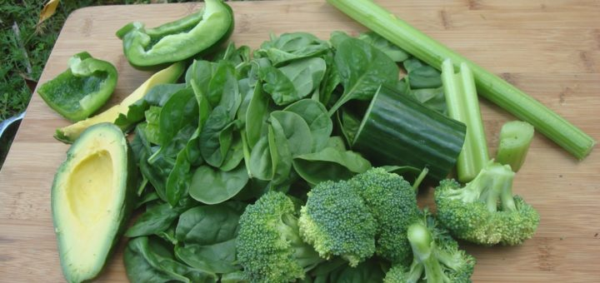

HYDRATION
70% of our earth is water, 70% of your body’s muscle weight is water, 75% of your lung’s capacity is water and 80% of your brain’s substance is water*. So therefore, why are we waiting until we are thirsty to drink? Water is the foundation of life. As a general rule of thumb, you should be drinking ½ your bodyweight in ounces daily.
e.g.: if you weigh 200lbs, you should drink 100 ounces per day.
1 ounce = 0.06 pints or 30ml
*source: https://www.medicalnewstoday.com/articles/what-percentage-of-the-human-body-is-water#where-in-the-body

GO GREEN!
Modern day society has foods so easily accessible, that we often do not truly understand the effects some foods are having on our bodies. In the western world, the majority of our diet is based around a starchy carbohydrate, protein and a small portion of fruits/vegetables (greens). We need to flip this ratio. For optimal health and vitality and for your body to be able to perform in a peak state we need 70% GREENS, 20% Carbohydrates and 10% Protein.

ALKALINE vs ACID
Simply put, overweight = overacid. Your body thrives in an environment that’s alkaline and barely survives in an environment that’s acidic. A highly acidic environment in your body can promote health issues such as cancers, heart disease, high blood pressure, digestive problems, skin abnormalities and more. Acidity is toxicity and the way to cleanse that is through alkalising your body. Look at the table below and become aware of how you can improve your health through some easy changes to your eating habits.

Highly Acidic Foods | OLD CHOICES | ENERGY & LIFE  PROMOTING ALTERNATIVES
Processed Fats | Butter, Sunflower & Rapeseed Oil, Deep fried foods, Crisps | Olive Oil, Nuts, Avocados, Omega 3 supplement
Animal Meats | Bacon, Sausages, Ham, Beef, Lamb, Pork | There are many meat-free alternative options.  If you wish to continue eating meat, ORGANIC!
Dairy | Cow’s milk, Cheese | Almond milk, oat milk, cashew milk, hazelnut milk, vegan cheese
Refined Sugar | Excessive caffeine, excessive alcohol, processed/granulated sugar, cereals, processed vinegar | Oats, herbal teas, hot lemon water

‘If God made it, eat it, if man made it, leave it!’
Dr. Mark Hyman
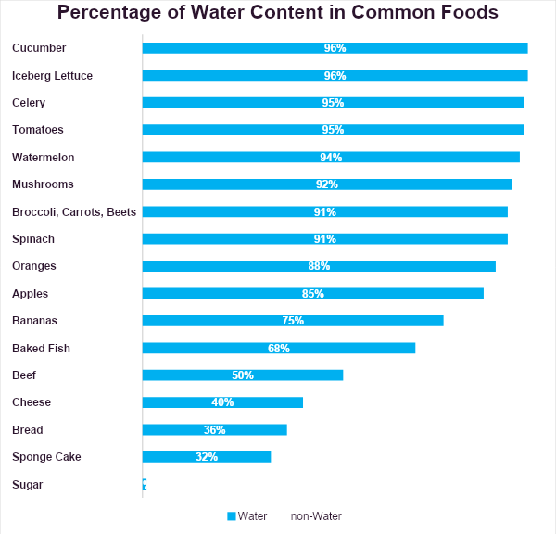
The guidance listed above is intended to guide you with alternative choices that will promote your health and wellbeing. Please note, this does not mean you have to cut out everything entirely! We all enjoy a pizza, chocolate cake or a sweet treat every now and again, but as the old adage goes, EVERYTHING IN MODERATION! If you consume a highly acidic food or drink, don’t put yourself down or quit or think you’ve failed, all you have to do is supplement your next meal with some additional greens or water-based food. Use this as a technique moving forward:
For every highly acidic food you eat, you must have double the amount of greens / water-based food in your meal. Keep your ratios correct and your hydration high!
Use the area below to take key notes, brainstorm ideas and create plans for the week:
MENTAL STRENGTH & RESILIENCE:
Key notes:

ACTION PLAN FOR THE WEEK:
Ideas how I can apply into my life:

Use this space below to record your progress. Note down how you feel the day went, what went well, what can you improve on and any other relevant comments.

MONDAY:

TUESDAY:

WEDNESDAY:

THURSDAY:

FRIDAY:

WEEKEND:
At the end of each week, use the space below to write down key non-negotiable habits that you have learnt, implemented and why you know this will help breed success in this area of your life:

Use the area below to take key notes, brainstorm ideas and create plans for the week:
THE KEYS TO FULFILMENT IN LIFE:
Key notes:

ACTION PLAN FOR THE WEEK:
Ideas how I can apply into my life:

Use this space below to record your progress. Note down how you feel the day went, what went well, what can you improve on and any other relevant comments.

MONDAY:

TUESDAY:

WEDNESDAY:

THURSDAY:

FRIDAY:

WEEKEND:
At the end of each week, use the space below to write down key non-negotiable habits that you have learnt, implemented and why you know this will help breed success in this area of your life:

Everything you have achieved during the course of this 8-week programme has been down to the decisions you have made, commitment you have shown and the resilience you have demonstrated.
The results you now attain are a direct reflection of the standards you have held yourself to during this challenge. The energy, vitality, optimism and peak health state you now experience is due to the fact you have shown up for yourself consistently.
Now, is where your new level of performance truly begins…
KEEPING UP YOUR MOMENTUM.
As I stated at the start of this experience, my goal was for this programme e to serve as a catalyst for you to explore new levels of mindset and mental capacity. To continue your progress, use everything you have learnt and harnessed during the past 56 days to create a compelling future and a life on your terms. If you want to continue to enhance your Life & Mindset, what is next for you? What else would you like to achieve? My wish is for you to continue your momentum and the great work you have started. Let this not be a fleeting moment but a new standard that you commit to from here on out. Surround yourself with people who inspire you and make you grow, find role models who can help you achieve the goals you want and find new and exciting ways to expand your mindset and mental outlook on life. That is where the greatest joys are found.
Use this workbook as a foundation. Work back through your notes and identify where you have improved, and where there is still room for improvement. If you set yourself a new goal, use the same principles outlined during these past 8 weeks to ensure you have the strategies needed to attain the success you desire.
If at any stage I can help you moving forward in any way, please do not hesitate to contact me at any time.
Until then, continue to UNLEASH YOUR TRUE POTENTIAL!
Your coach,
Matt

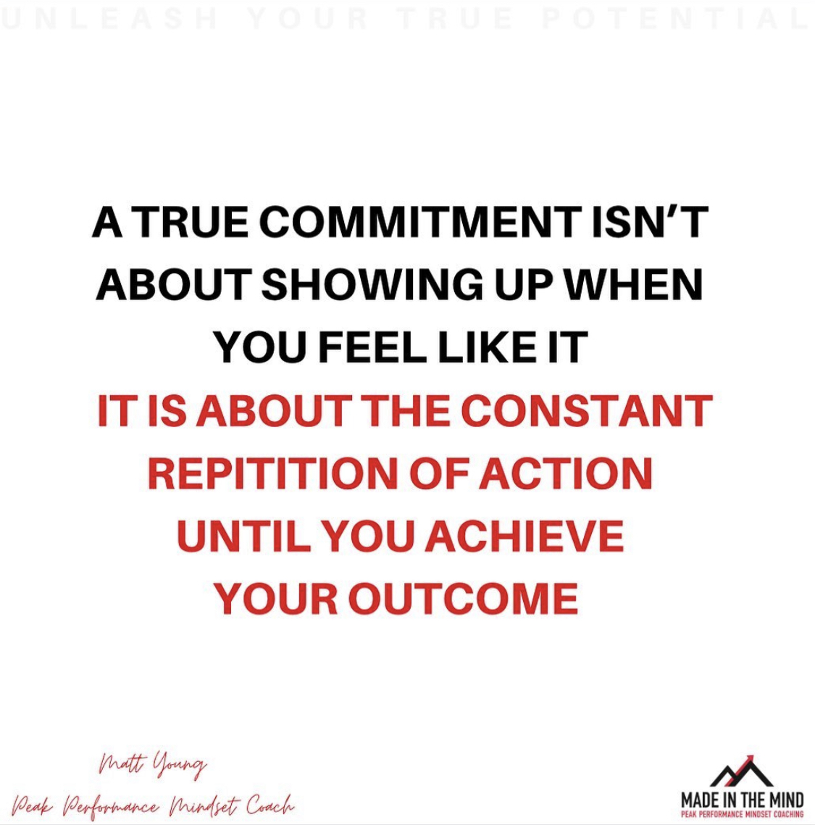

CAN’T HURT ME by David Goggins
Written by former US Navy Seal, David Goggins is a man who epitomises what it means to perform at a peak level. For anyone who is interested in the limitless possibilities of your mind and body, this book will transform your thinking into what is humanly possible. I read this book in 2019 and it has been the biggest external factor in motivating me to run 7 x Ultra Marathons and 5 x Marathons in less than 18 months.

MAN’S SEARCH FOR MEANING by Viktor E. Frankl
This book is a must. A must for anyone who is looking to broaden their perspective on life and gain insight into how powerful and capable the human mind really is. A real life memoir from a neurologist and psychiatrist regarding his experiences throughout the Holocaust, this book depicts a simple message that I think we can all learn from: You can take everything from me, but you can’t take my mind.

THE TALENT CODE by Daniel Coyle
Want to know how the peak performers have become so great? This book is revolutionary. You will understand how all talent can be harnessed, nurtured and grown to any level of performance you desire. Revealing real life stories and scientific evidence, this book is a game changer! If there has ever been a time you thought you didn’t have the ability or talent to do something, you need to read this book!

+44 (0) 7738 635 195

matt@madeinthemind.com

www.madeinthemind.com

@mattyoungr
@madeinthemind_

